**1. WAP in C to check whether an input character is alphabet, digit or special symbol?**

**Code:**

#include<stdio.h>

#include<conio.h>

int main() {

char ch;

int asciiCode;

printf("Enter any character: ");

scanf("%c", &ch);

asciiCode = ch;

// Check character is number.

If (asciiCode >= 48 && asciiCode <= 57) {

printf("Character '%c' is an number.", ch);

}

// Check character is alphabet.

else if ((asciiCode >= 65 && asciiCode <= 90) || (asciiCode >= 97 && asciiCode <= 122)) {

printf("Character '%c' is an Alphabet.", ch);

}

// Check character is special symbol.

else {

printf("Character '%c' is an special symbol", ch);

}

return 0;

}

**Output:**

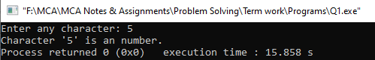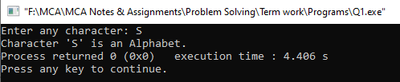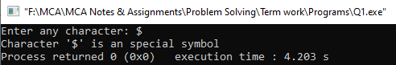

**2. WAP in C to check whether a triangle is valid or not by providing all the sides. If valid then check whether the triangle is equilateral, isosceles, or scalene?**

**Code:**

#include<stdio.h>

#include<conio.h>

int main(){

int side1, side2, side3;

printf("Enter three sides of the triangle:");

scanf("%d%d%d", &side1, &side2, &side3);

// Triangle is valid.

if(side1 + side2 > side3 && side1 + side3 > side2 && side2 + side3 > side1)

{

// Check Equilateral Triangle.

if(side1 == side2 && side1 == side3 && side2 == side3){

printf("The triangle you entered is a Equilateral Triangle.");

}

// Check Isosceles Triangle.

else if(side1 == side2 || side1 == side3 || side2 == side3){

printf("The triangle you entered is a Isosceles Triangle.");

}

// Check Scalene Triangle.

else{

printf("The triangle you entered is a Scalene Triangle.");

}

}

// Triangle is Invalid.

else{

printf("The triangle is invalid!");

}

getch();

return 0;

}

**Output:**

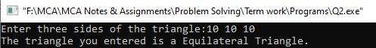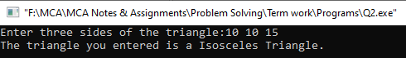

**3. WAP in C to enter the marks in three subjects for a student and find percentage and Scholarship. Rules for the semester scholarship are as follows:**

**Below 50 = 0**

**51 to 60 = 5%**

**61 to 74 = 20%**

**75 to 84 = 30%**

**85 & above = 50%**

**Semester fee is Rs. 125000/- print the net amount payable.**

**Ask the user to enter marks in 5 subjects and display the corresponding grade.**

**4. WAP in C to check whether an input year is leap-year or not?**

**Code:**

#include<stdio.h>

#include<conio.h>

int main() {

int year;

printf("Enter any year to check whether it is a leap year or not: ");

scanf("%d", &year);

if(year%4 == 0 || (year%100 == 0 && year%400 == 0 )) {

printf("The year %d is a leap year", year);

}

else {

printf("The year %d is not a leap year", year);

}

return 0;

}

**Output:**

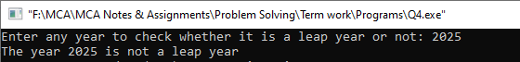

**5. Write a program in C to print first n palindrome number.**

**Code:**

#include<stdio.h>

#include<conio.h>

int checkNumberIsPalindrome(int n){

int num = n, reversed = 0, remainder;

while(num != 0){

remainder = num%10;

reversed = reversed * 10 + remainder;

num = num/10;

}

if(reversed == n){ return 1; }

else{ return 0; }

}

int main(){

int size, count = 0, num = 0, result;

printf("Enter how much first palindrome numbers you want: ");

scanf("%d", &size);

while(count <= size){

result = checkNumberIsPalindrome(num);

if(result != 0){

printf("\n%d", num);

count++;

}

num++;

}

return 0;

}

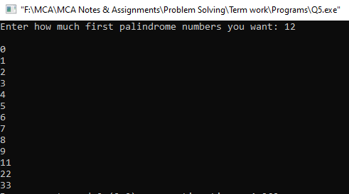**Output:**

**6. Write a program in C to convert a Decimal number into Binary, Octal and Hexadecimal number.**

**Code:**

#include<stdio.h>

#include<conio.h>

#include<stdlib.h>

int main(){

int number, rem, base, choice, index = -1;

char result[100], ch;

printf("Enter any decimal number: ");

scanf("%d", &number);

printf("1. Convert into Binary \n");

printf("2. Convert into Octal \n");

printf("3. Convert into HexaDecimal \n");

printf("Please enter your choice: ");

scanf("%d", &choice);

switch(choice){

case 1:

base = 2; break;

case 2:

base = 8; break;

case 3:

base = 16; break;

default:

printf("Invalid choice!!"); exit(0);

}

while(number != 0){

rem = number%base;

switch(rem){

case 10:

ch = 'A'; break;

case 11:

ch = 'B'; break;

case 12:

ch = 'C'; break;

case 13:

ch = 'D'; break;

case 14:

ch = 'E'; break;

case 15:

ch = 'F'; break;

default:

ch = rem+48; break;

}

index++;

result[index] = ch;

number = number/base;

}

for(int i = index; i >= 0; i--)

{

printf("%c", result[i]);

}

return 0;

}

**Output:**

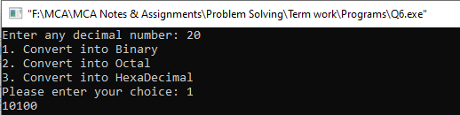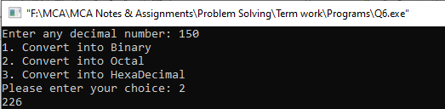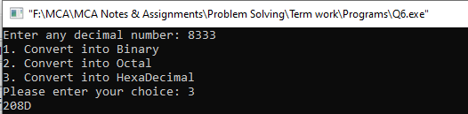

**7. Write a C program to print the digits of a number in words.**

**Sample example of Output will be:**

**Enter any number: 2481**

**Two Four Eight One**

**Code:**

#include<stdio.h>

#include<conio.h>

int main(){

char ch[10][10] = {"Zero", "One", "Two", "Three", "Four", "Five", "Six", "Saven", "Eight", "Nine"};

int digits[50];

int number, index = -1;

printf("Enter any Integer number: ");

scanf("%d", &number);

while(number!=0){

index++;

digits[index] = number%10;

number = number/10;

}

for(int i = index; i>=0; i--){

printf("%s ", ch[digits[i]]);

}

return 0;

}

**Output:**

**Problem Statement 8:** Write a C program to compute the sum of first N terms for the following series.

1. S=1 + 22/2! + 33/3! + 44/4! + …
2. S=1 + 2/2! + 32/3! + 43/4! + …
3. S=1 -2! + 3! - 4! + 5! -6! + …

**(i) S=1 + 22/2! + 33/3! + 44/4! + …**

**Code:**

#include<stdio.h>

#include<conio.h>

int fact(int num);

int power(int num, int pow);

int main(){

int number;

float sum = 0, term;

printf("Enter any number of terms: ");

scanf("%d", &number);

for(int i = 1; i<=number; i++){

term = (float)power(i, i)/fact(i);

sum += term;

}

printf("The sum of the series is: %f", sum);

return 0;

}

int fact(int num){

if(num <= 1)

{ return num; }

else

{ return num * fact(num-1); }

}

int power(int num, int pow){

if(pow == 0){ return 1; }

int result = num;

for(int i=2; i<=pow; i++){

result = result * num;

}

return result;

}

**Output:**

**(ii) S=1 + 2/2! + 32/3! + 43/4! + …**

**Code:**

#include<stdio.h>

#include<conio.h>

int fact(int num);

int power(int num, int pow);

int main(){

int number;

float sum = 0, term;

printf("Enter any number of terms: ");

scanf("%d", &number);

for(int i = 1; i<=number; i++){

term = (float)power(i, i-1)/fact(i);

sum += term;

}

printf("The sum of the series is: %f", sum);

return 0;

}

int fact(int num){

if(num <= 1)

{ return num; }

else

{ return num * fact(num-1); }

}

int power(int num, int pow){

if(pow == 0){ return 1; }

int result = num;

for(int i=2; i<=pow; i++){

result = result * num;

}

return result;

}

**Output:**

**(iii) S=1 -2! + 3! - 4! + 5! -6! + …**

**Code:**

#include<stdio.h>

#include<conio.h>

int fact(int num);

int main(){

int number, sum = 0, term;

printf("Enter any number of terms: ");

scanf("%d", &number);

for(int i = 1; i<=number; i++){

term = fact(i);

if(i%2 == 0){

sum -= term;

}

else{

sum += term;

}

}

printf("The sum of the series is: %d", sum);

return 0;

}

int fact(int num){

if(num <= 1)

{ return num; }

else

{ return num * fact(num-1); }

}

**Output:**

**9. Write a program in C to find out the highest common factor (HCF) and lowest common multiple (LCM) of two number.**

**10. Write C code to print the following patterns:**

**(i) (ii)**

**1 E**

**1 2 1 E D E**

**1 2 3 2 1 E D C D E**

**1 2 3 4 3 2 1 E D C B C D E**

**1 2 3 4 5 4 3 2 1 E D C B A B C D E**

**1 2 3 4 3 2 1 E D C B C D E**

**1 2 3 2 1 E D C D E**

**1 2 1 E D E**

**1 E**

**(i) Code:**

#include<stdio.h>

#include<conio.h>

int main(){

int n, num;

printf("Enter number of rows: ");

scanf("%d", &n);

for(int i=1; i<=n; i++){

for(int s=1; s<=n-i; s++){

printf(" ");

}

num = 0;

for(int j=1; j<=2*i-1; j++){

if(j <= i){

num++;

}

else{

num--;

}

printf("%d ", num);

}

printf("\n");

}

for(int i=1; i<n; i++){

for(int s=1; s<=i; s++){

printf(" ");

}

num = 0;

for(int j=1; j<=2*n-2*i-1; j++){

if(j<=n-i){

num++;

}

else{

num--;

}

printf("%d ", num);

}

printf("\n");

}

return 0;

}

**Output:**

**(ii) Code:**

#include<stdio.h>

#include<conio.h>

int main(){

int n, num;

printf("Enter the size of pattern: ");

scanf("%d", &n);

for(int i=1; i<=n; i++){

for(int s=1; s<=n-i; s++){

printf(" ");

}

num = n + 65;

for(int j=1; j<=2*i-1; j++){

if(j <= i){

num--;

}

else{

num++;

}

printf("%c ", num);

}

printf("\n");

}

for(int i=1; i<n; i++){

for(int s=1; s<=i; s++){

printf(" ");

}

num = n + 65;

for(int j=1; j<=2*n-2*i-1; j++){

if(j<=n-i){

num--;

}

else{

num++;

}

printf("%c ", num);

}

printf("\n");

}

return 0;

}

**Output:**

**11. WAP in C to input time in hour, minutes, and seconds. Display it in proper format. Then input two time-instance and add them and display the added time again in proper format.**

**First time is 10:12:34**

**Second time 21:21:59**

**Added time 31:34:33**

**Code:**

#include<stdio.h>

#include<conio.h>

struct Time{

int hours;

int minutes;

int seconds;

};

int main(){

struct Time firstTime, secondTime, addedTime;

int carry = 0;

printf("Enter the first time in hour, minute and seconds: ");

scanf("%d%d%d", &firstTime.hours, &firstTime.minutes, &firstTime.seconds);

printf("Enter the second time in hour, minute and seconds: ");

scanf("%d%d%d", &secondTime.hours, &secondTime.minutes, &secondTime.seconds);

// Adding times.

addedTime.seconds = firstTime.seconds + secondTime.seconds;

if(addedTime.seconds >= 60){

addedTime.seconds -= 60;

carry = 1;

}

addedTime.minutes = firstTime.minutes + secondTime.minutes + carry;

carry = 0;

if(addedTime.minutes >= 60){

addedTime.minutes -= 60;

carry = 1;

}

addedTime.hours = firstTime.hours + secondTime.hours + carry;

carry = 0;

printf("\nFirst Time- %d:%d:%d", firstTime.hours, firstTime.minutes, firstTime.seconds);

printf("\nLast Time- %d:%d:%d", secondTime.hours, secondTime.minutes, secondTime.seconds);

printf("\nAdded Time- %d:%d:%d", addedTime.hours, addedTime.minutes, addedTime.seconds);

return 0;

}

**Output:**